Отчет по лабораторной работе №9
Цель: научить использовать инструкции организации цикла.
Задание 1:
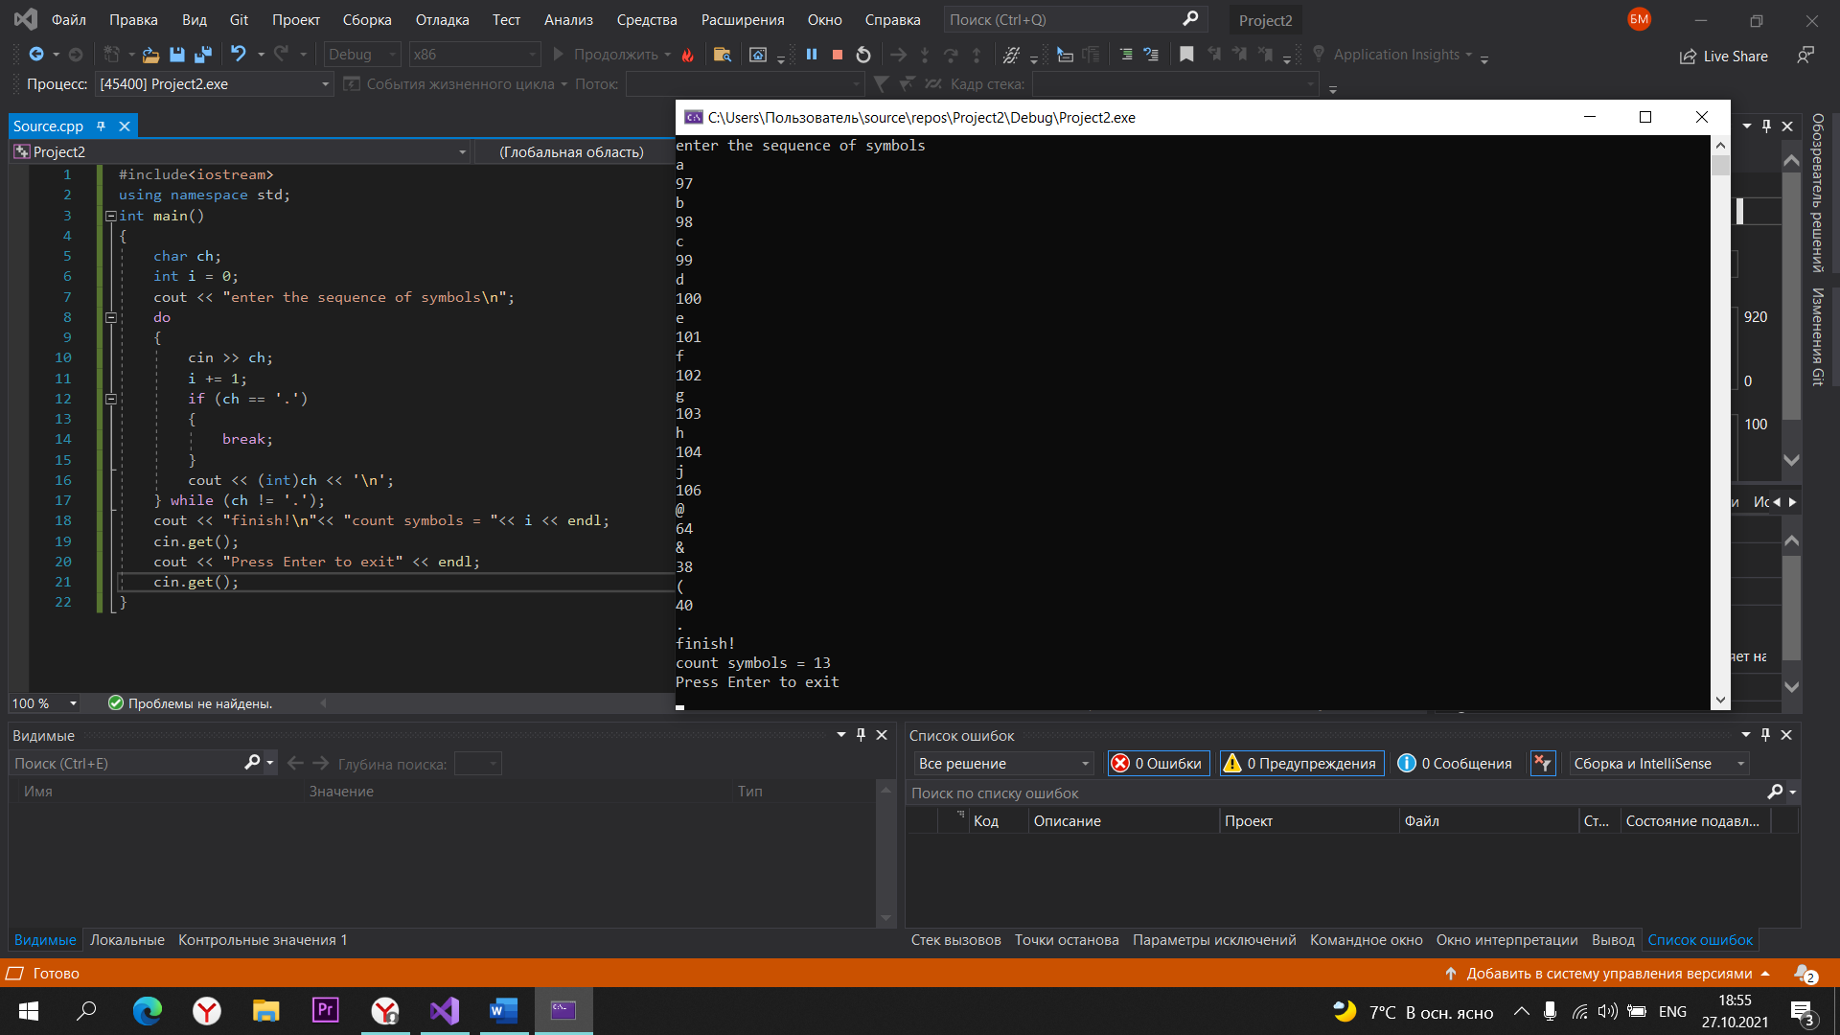

Code задание 1:
#include<iostream>
using namespace std;
int main()
{
char ch;
int i = 0;
cout << "enter the sequence of symbols\n";
do
{
cin >> ch;
i += 1;
if (ch == '.')
{
break;
}
cout << (int)ch << '\n';
} while (ch != '.');
cout << "finish!\n"<< "count symbols = "<< i << endl;
cin.get();
cout << "Press Enter to exit" << endl;
cin.get();
}
Задание 2:
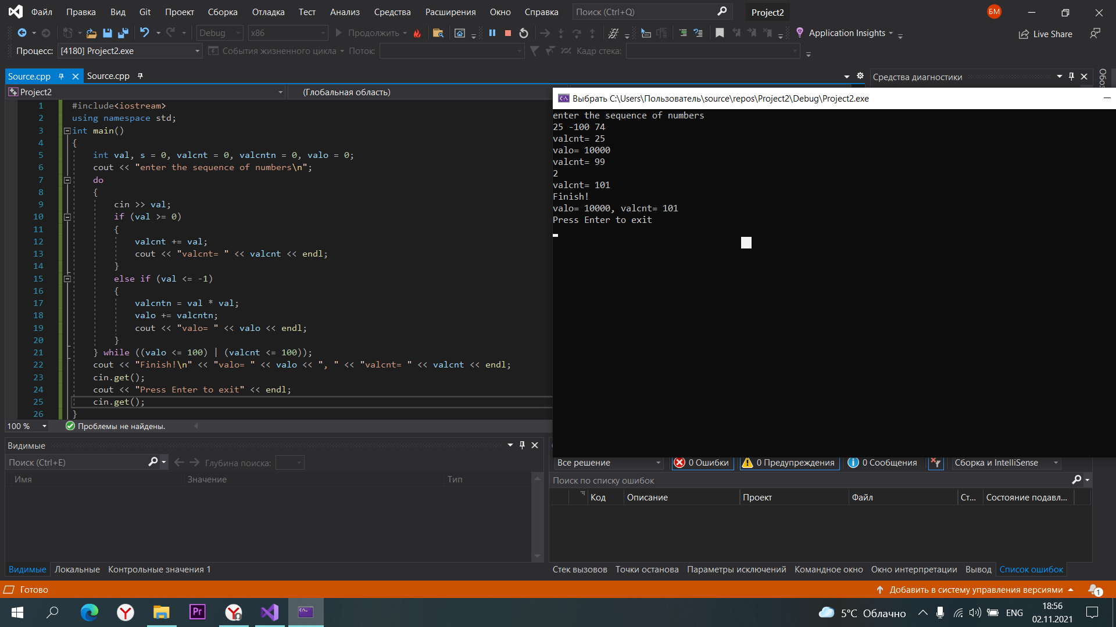
Code задание 2:
#include<iostream>
using namespace std;
int main()
{
int val, s = 0, valcnt = 0, valcntn = 0, valo = 0;
cout << "enter the sequence of numbers\n";
do
{
cin >> val;
if (val >= 0)
{
valcnt += val;
cout << "valcnt= " << valcnt << endl;
}
else if (val <= -1)
{
valcntn = val * val;
valo += valcntn;
cout << "valo= " << valo << endl;
}
} while ((valo <= 100) | (valcnt <= 100));
cout << "Finish!\n" << "valo= " << valo << ", " << "valcnt= " << valcnt << endl;
cin.get();
cout << "Press Enter to exit" << endl;
cin.get();
}
Задание 3:
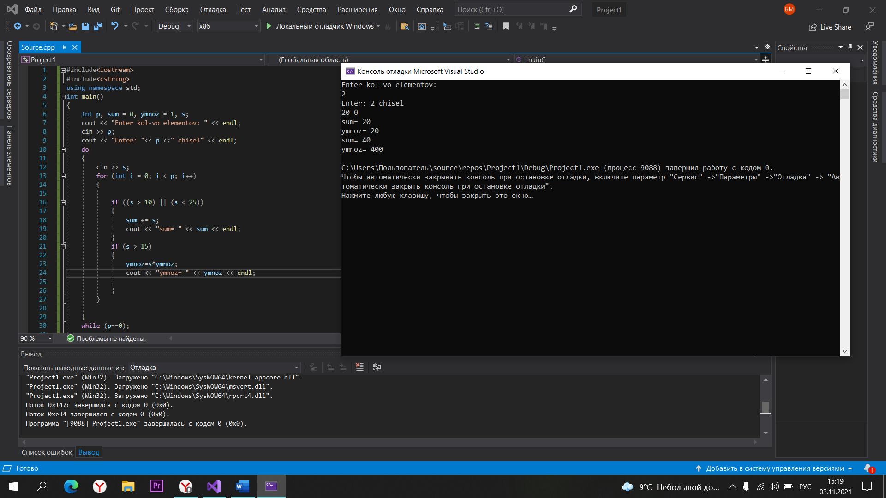
Code задание 3:
#include<iostream>
#include<cstring>
using namespace std;
int main()
{
int p, sum = 0, ymnoz = 1, s;
cout << "Enter kol-vo elementov: " << endl;
cin >> p;
cout << "Enter: "<< p <<" chisel" << endl;
do
{
cin >> s;
for (int i = 0; i < p; i++)
{

if ((s > 10) || (s < 25))
{
sum += s;
cout << "sum= " << sum << endl;
}
if (s > 15)
{
ymnoz=s*ymnoz;
cout << "ymnoz= " << ymnoz << endl;

}
}

}
while (p==0);

cin.get();
cin.get();
}
Задание 3:
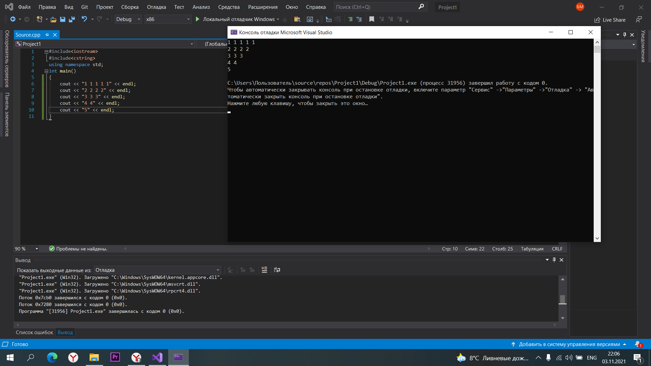
Code задание 3:
#include<iostream>
#include<cstring>
using namespace std;
int main()
{
cout << "1 1 1 1 1" << endl;
cout << "2 2 2 2" << endl;
cout << "3 3 3" << endl;
cout << "4 4" << endl;
cout << "5" << endl;
}
Задание 4:
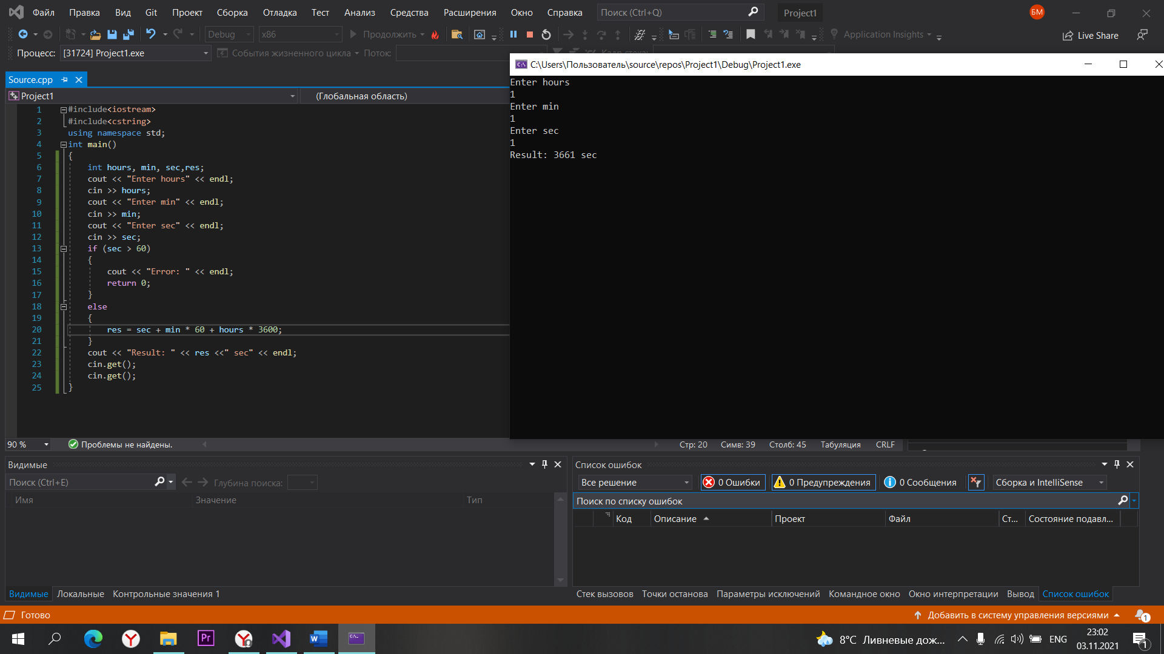

Code задание 4:
#include<iostream>
using namespace std;
int main()
{
int hours, min, sec,res;
cout << "Enter hours" << endl;
cin >> hours;
cout << "Enter min" << endl;
cin >> min;
cout << "Enter sec" << endl;
cin >> sec;
if (sec > 60)
{
cout << "Error: " << endl;
return 0;
}
else
{
res = sec + min * 60 + hours * 3600;
}
cout << "Result: " << res <<" sec" << endl;
cin.get();
cin.get();
}

